Defense evasion bits admin download:
Since case is related to bitsadmin so start search with keyword bitsadmin Download T1197.md
Which is named as bitsadmin1_flag.ps1
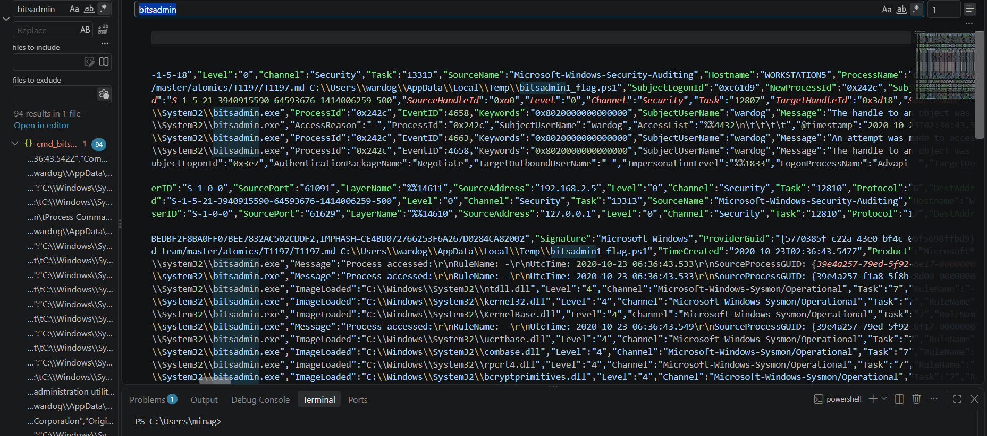

Search for bitsadmin1_flag.ps1 and there is no further activity. Observed.

Overall activity:
Bitsamin.exe downloads T1197.md which is renamed to bitsadmin1_flag.ps1 and is executed. No further activity activity is observed.

